SYDNEY ROOSTERS ADMINISTRATION – SYSTEM PROCEDURES

RETURNING PLAYER REGISTATION (played or registered before)
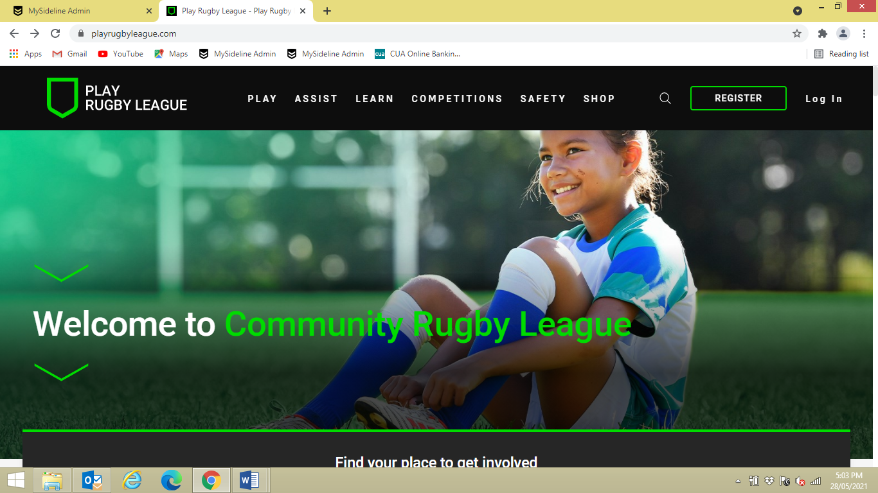
- www.playnrl.com
- Click REGISTER
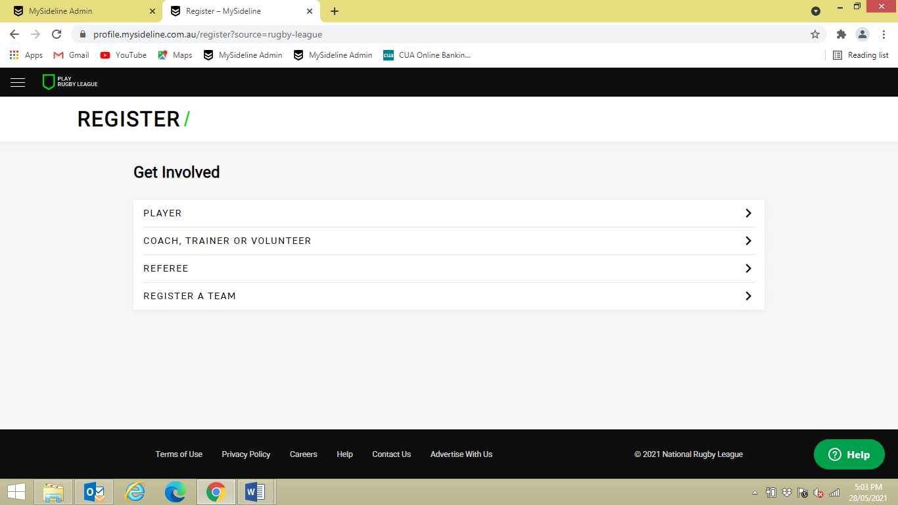
- Select option e.g. PLAYER
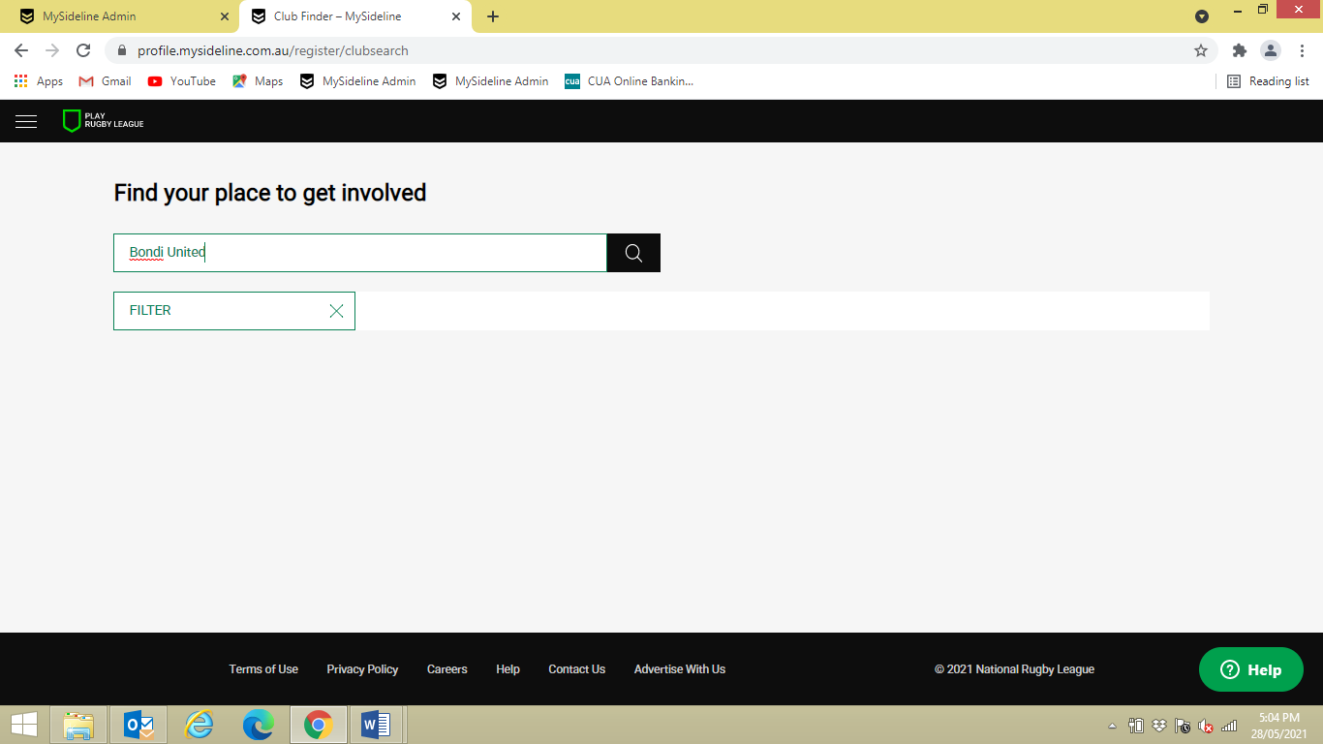
- Type in club you are wishing to play for
- Click on search button
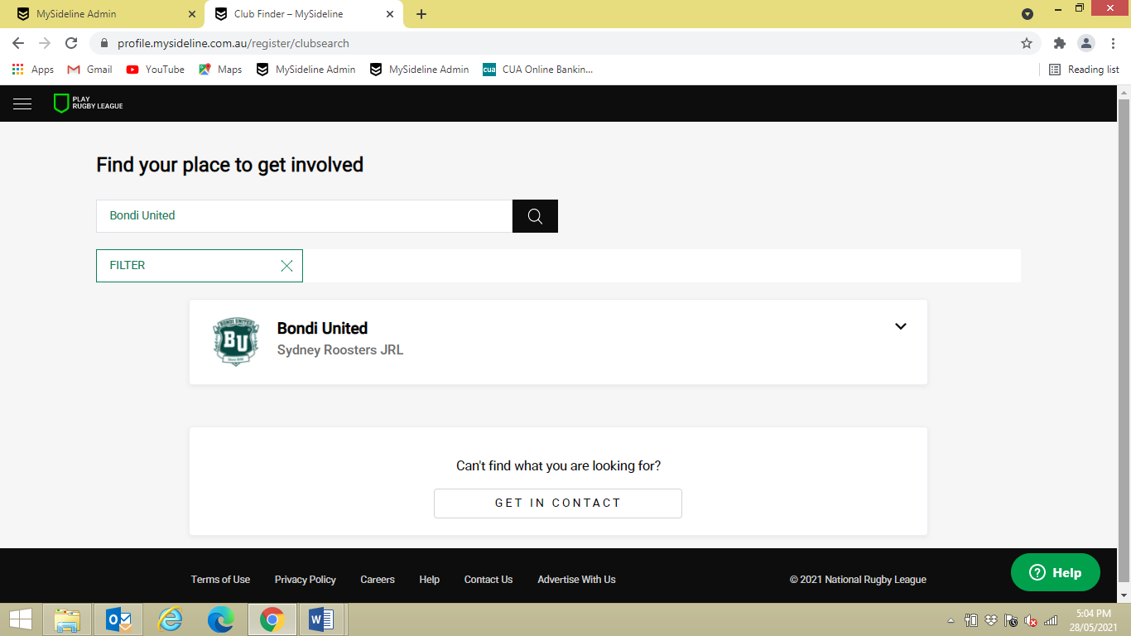
- Click on CLUB
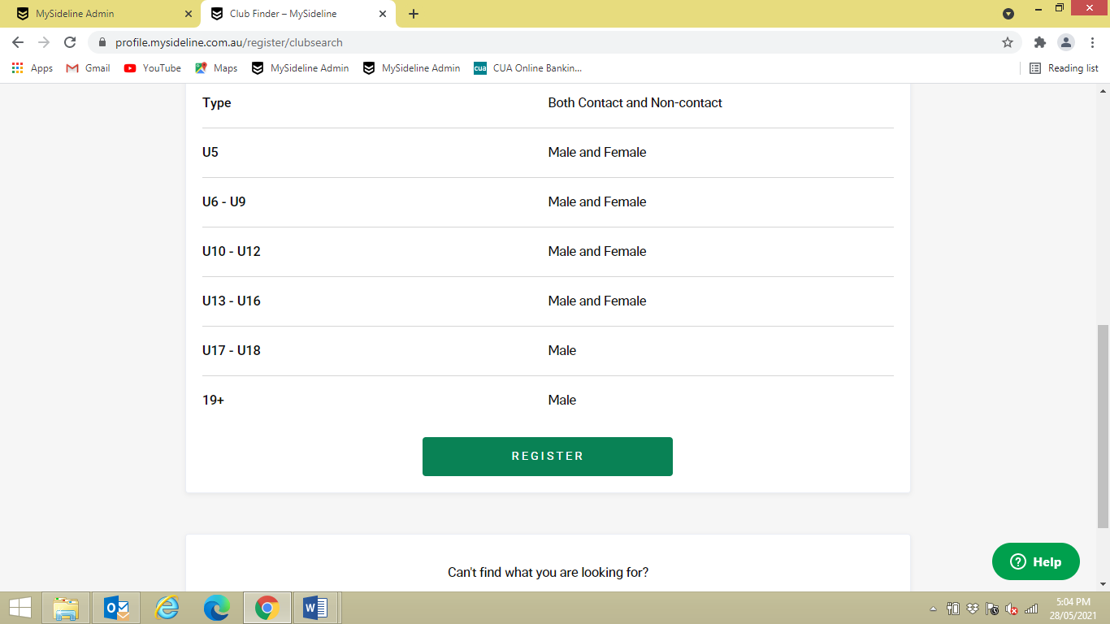
- Click on REGISTER
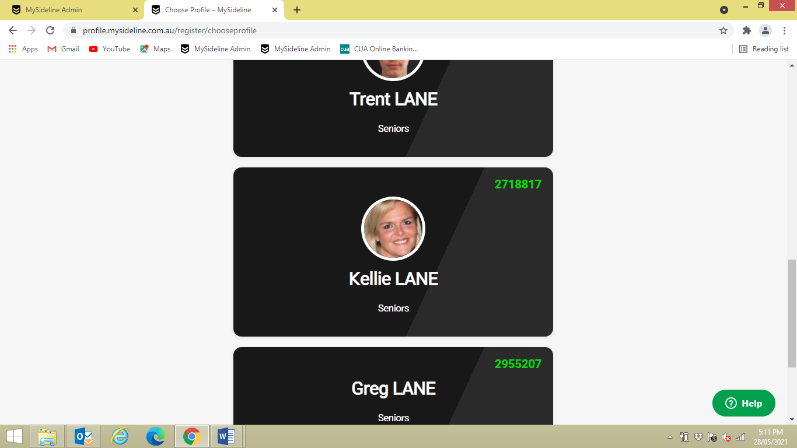
- Select PROFILE that you are registering

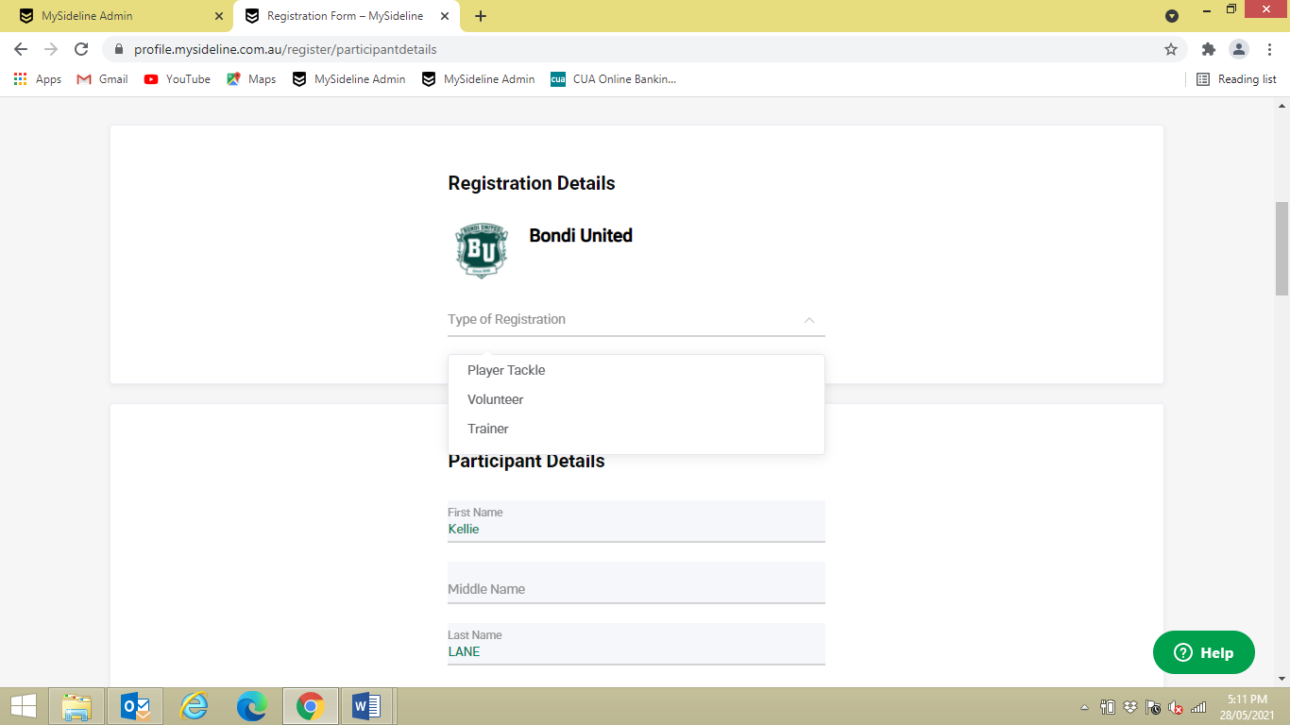
- Select type of registration from drop down box e.g. PLAYER TACKLE
- Complete PARTICIPANT DETAILS

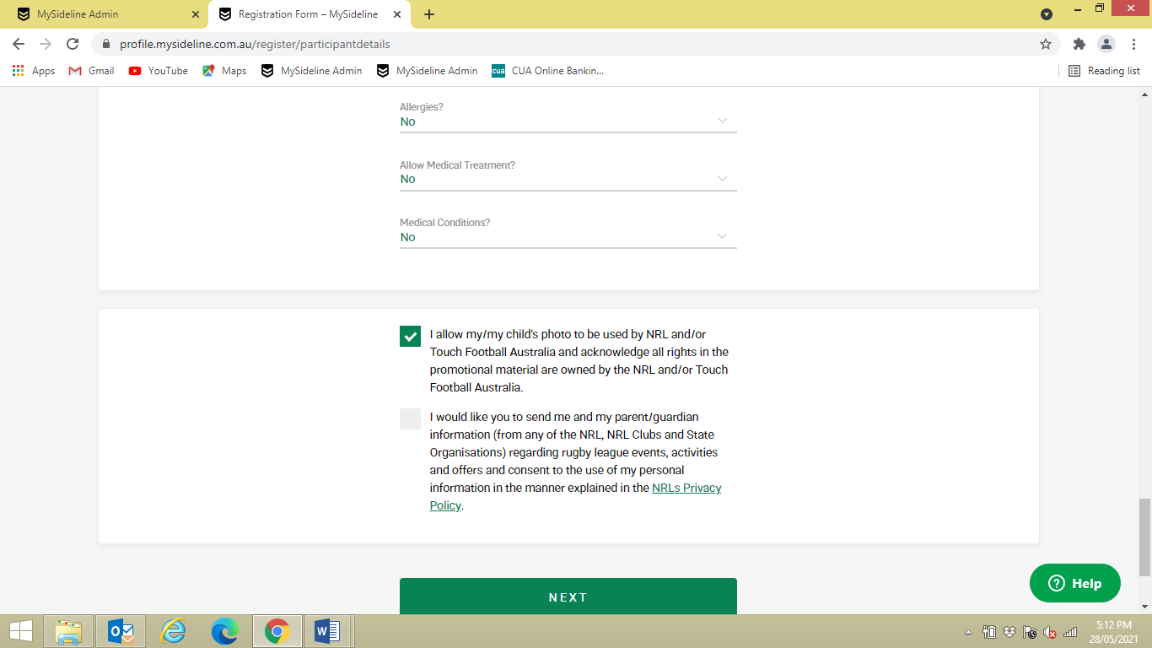
- Complete MEDICAL QUESTIONS
- TICK boxes regarding NRL
- Select NEXT

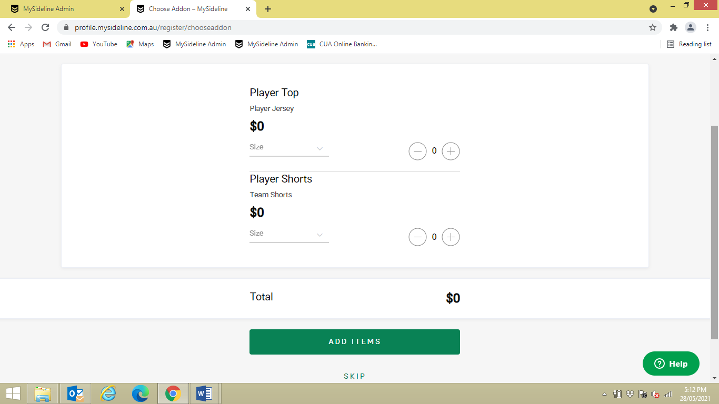
- ADD ITEMS is optional depends on each club OR
- Select SKIP

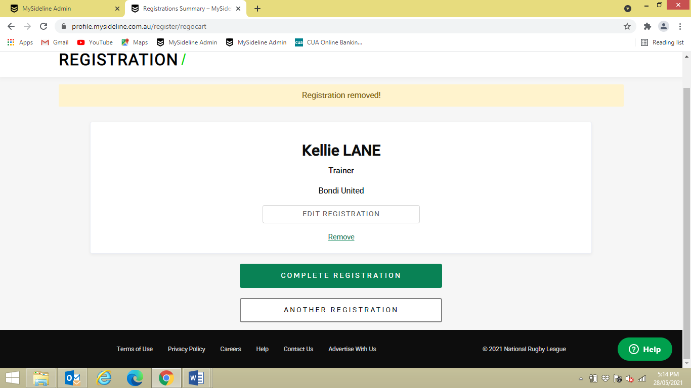
- Select COMPLETE REGISTRATION

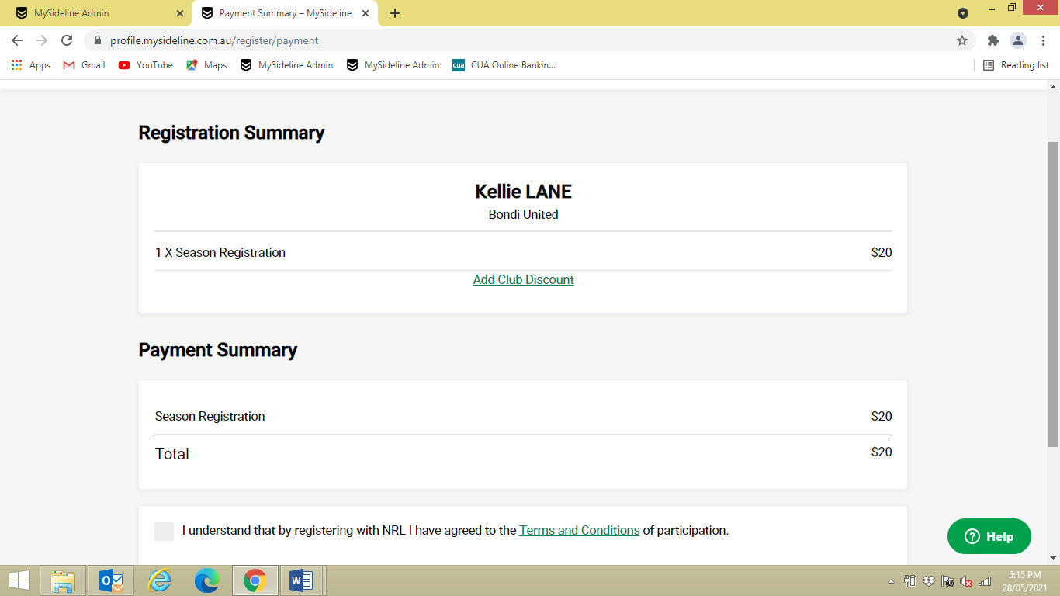

- ADD CLUB DISCOUNT this is where you add a VOUCHER CODE if club emails you one
- At this point it will ask to add ACTIVE KIDS VOUCHER

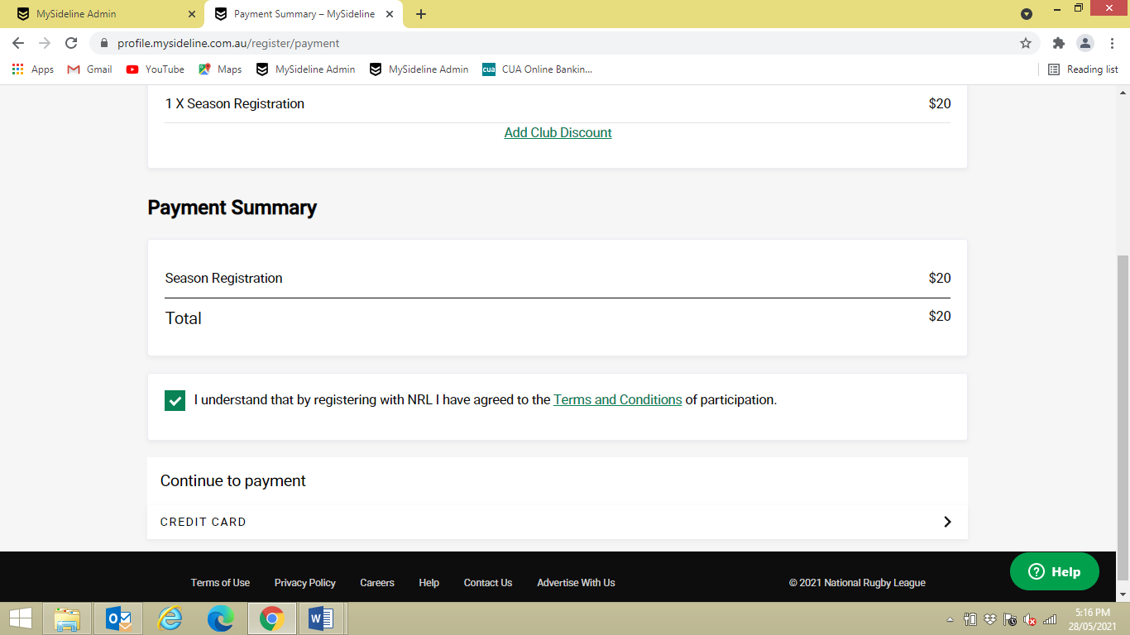
- Tick box TERMS AND CONDITIONS
- Click on CONTINUE TO PAYMENT

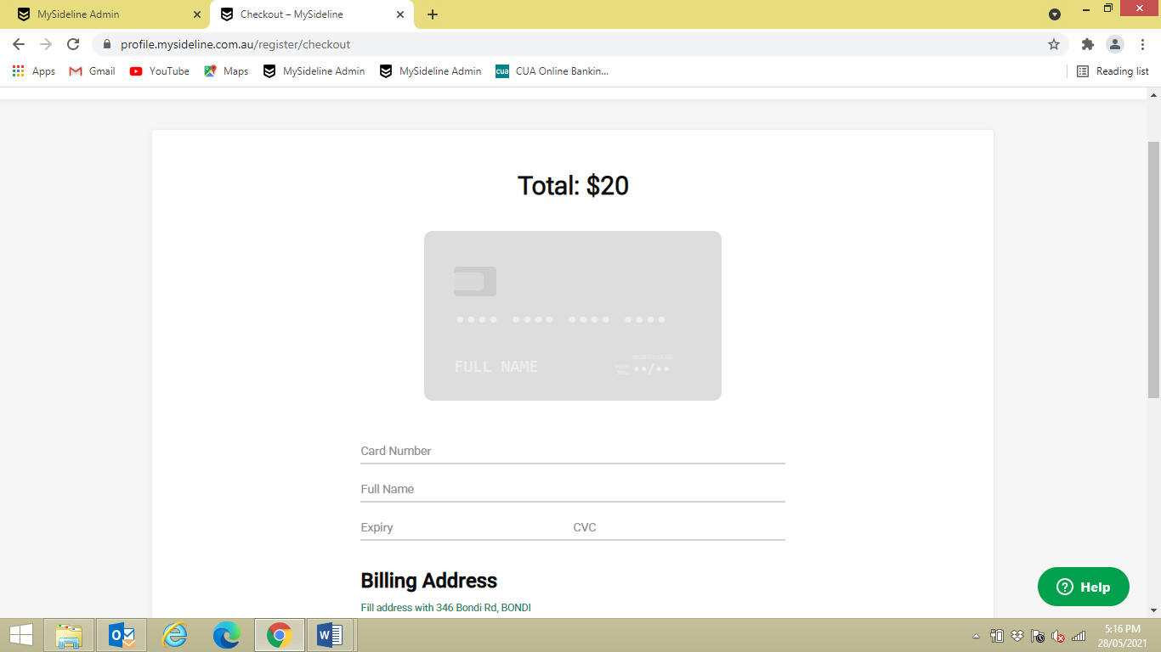

- Enter CREDIT CARD DETAILS

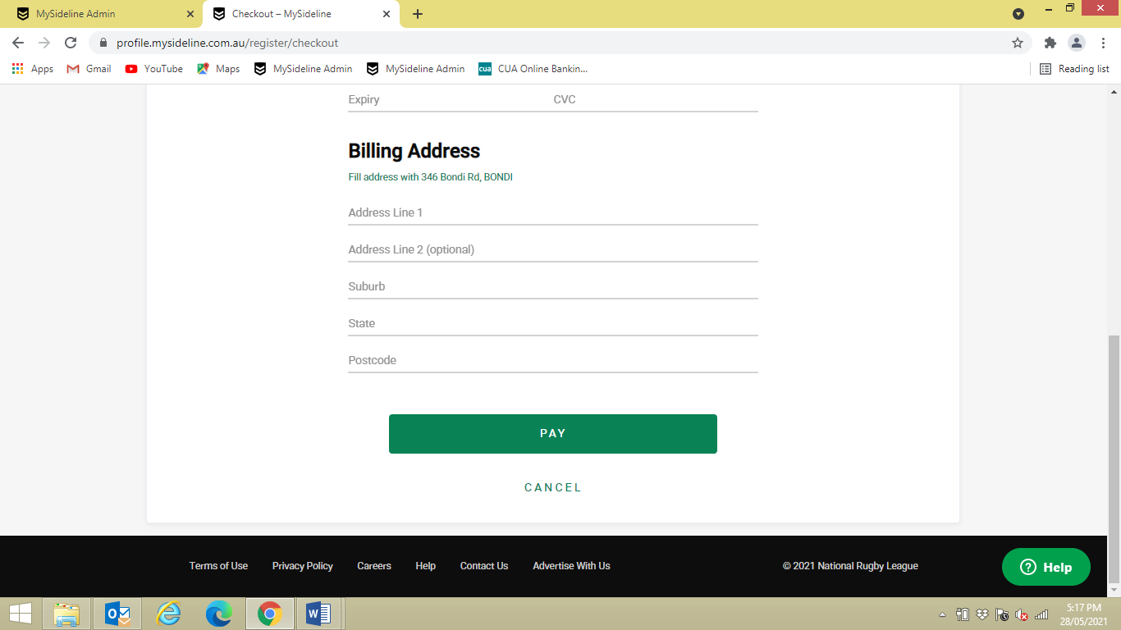
- Complete BILLING ADDRESS
- Click on PAY
- REISTRATION on now complete

CHANGING YOUR PROFILE PERSONAL DETAILS
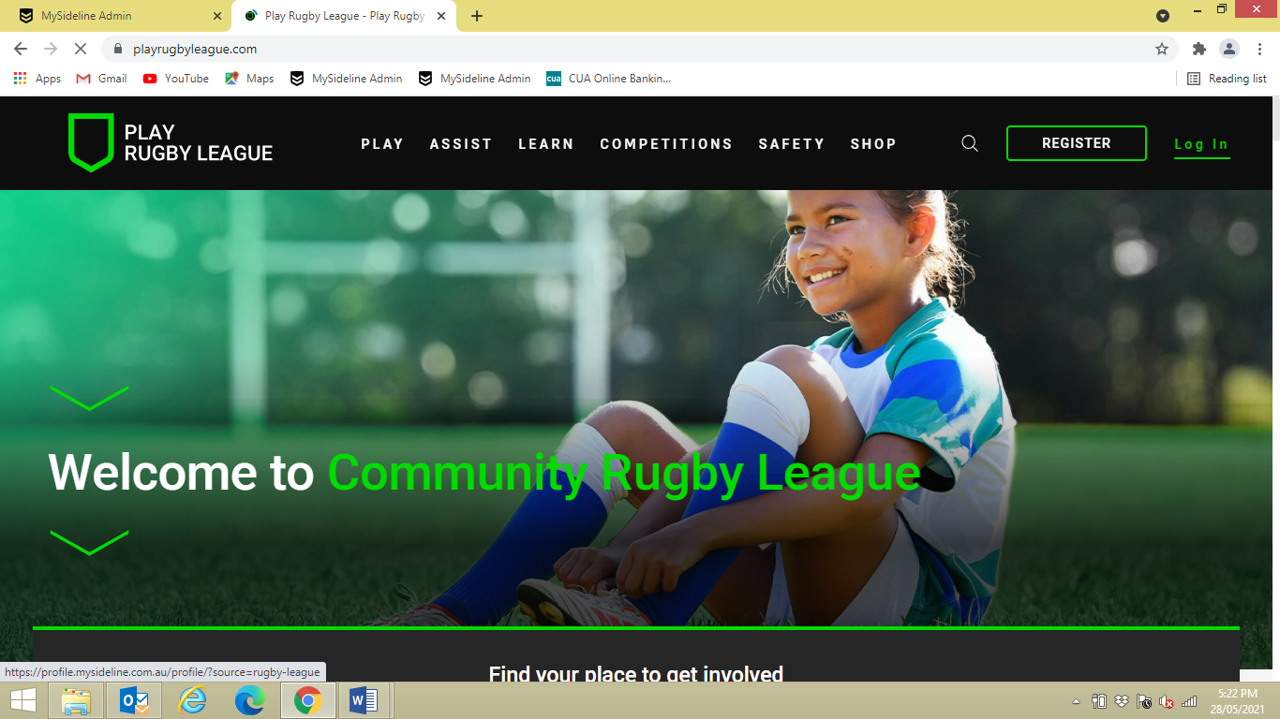
- LOG IN to update personal details

