SYDNEY ROOSTERS ADMINISTRATION – SYSTEM PROCEDURES

Mysideline Manager – STEPS P 1

NOTE – Game day list needs to be completed by the Thursday before each game
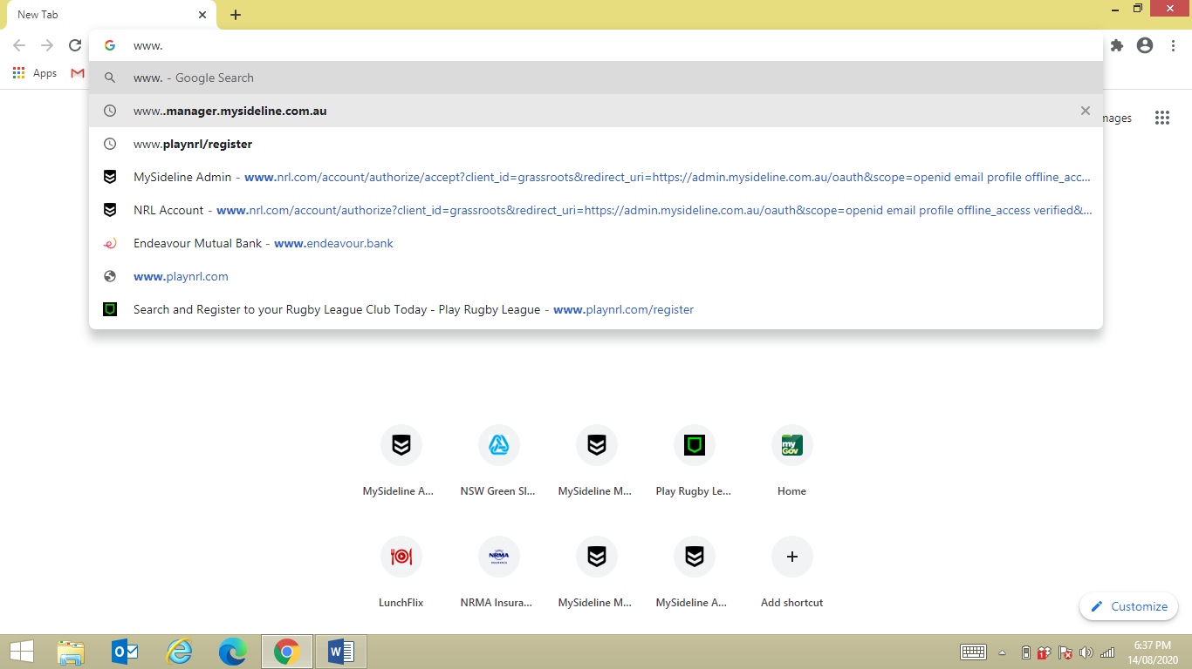
P 2
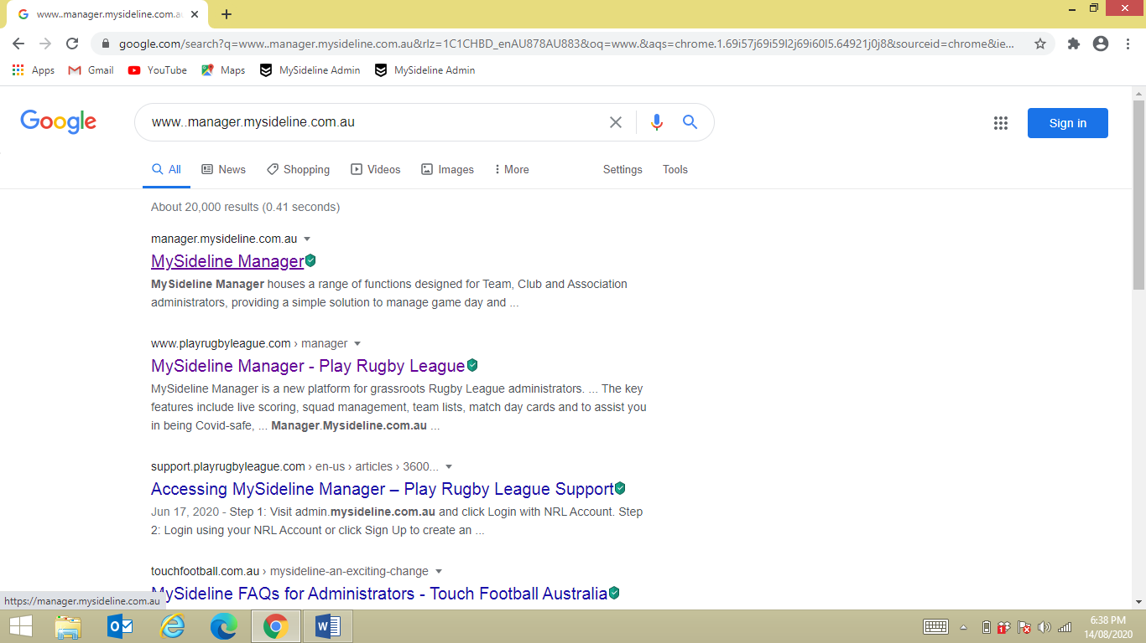

P 3

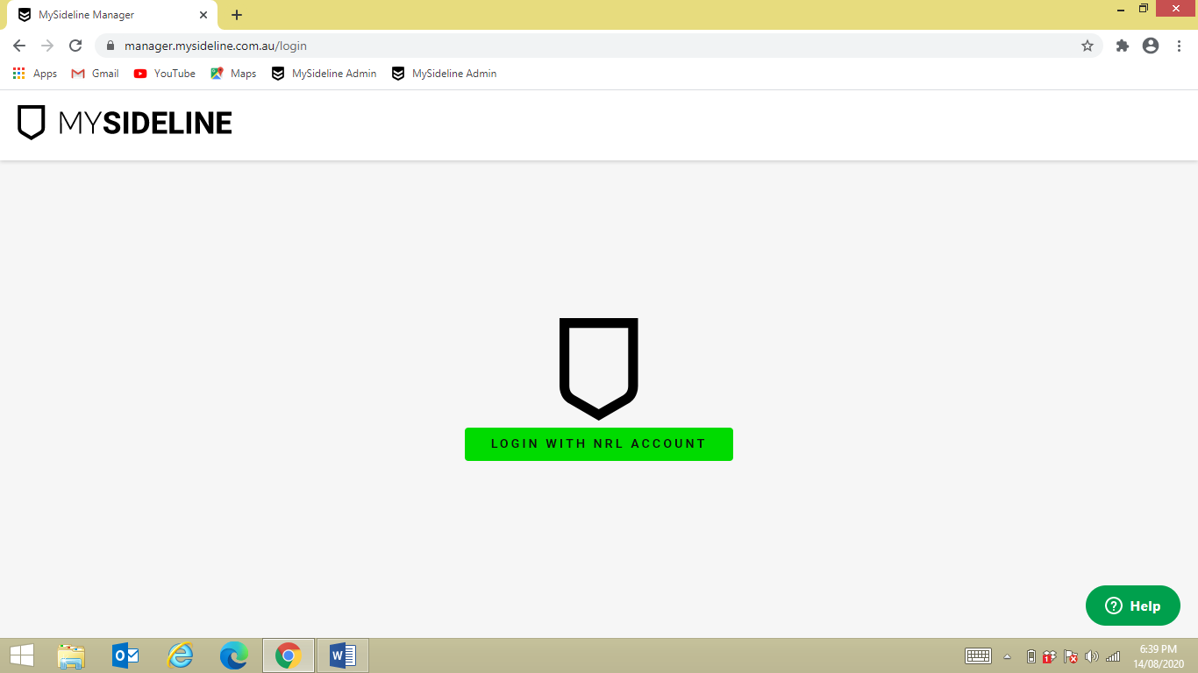

P 4

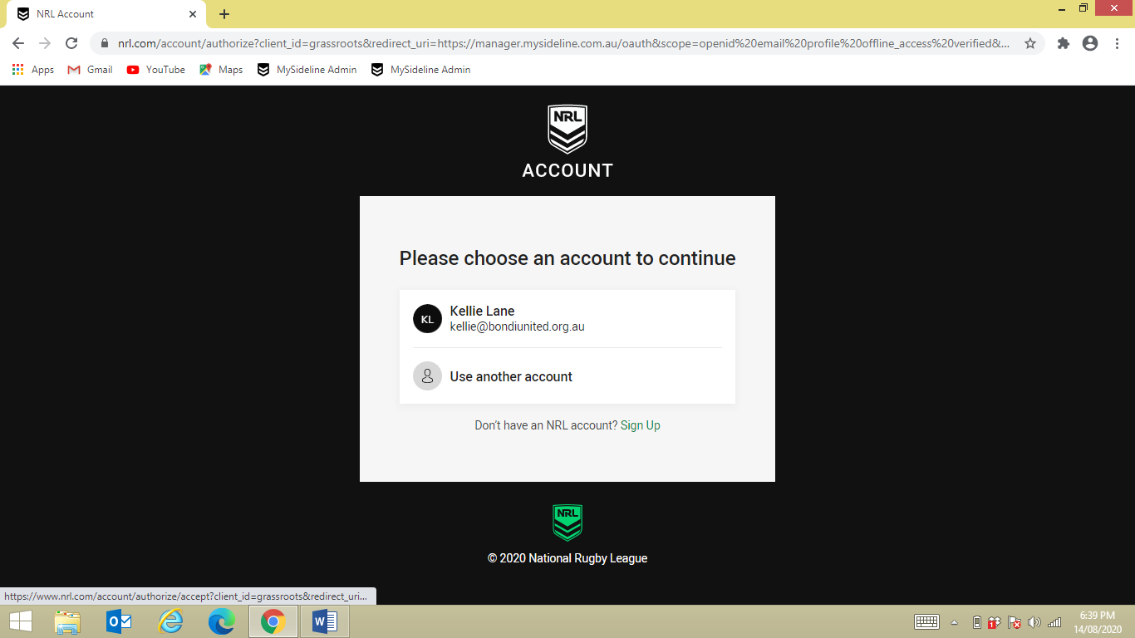
- LOGIN

P 5

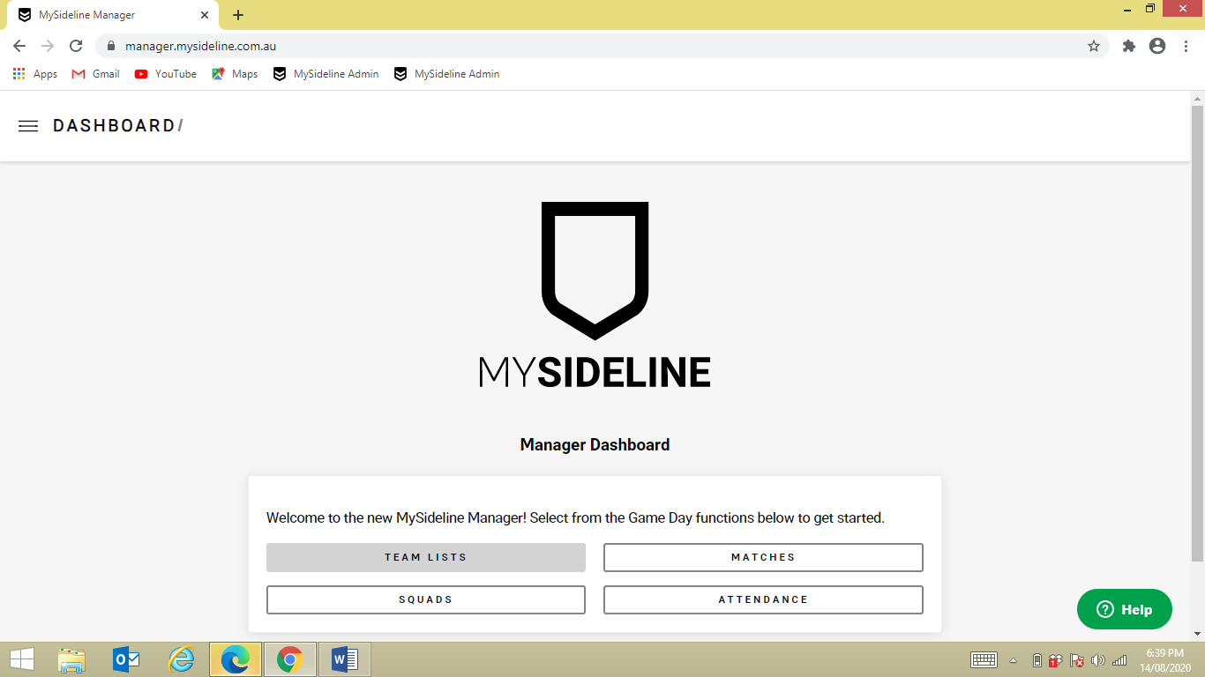

P 6

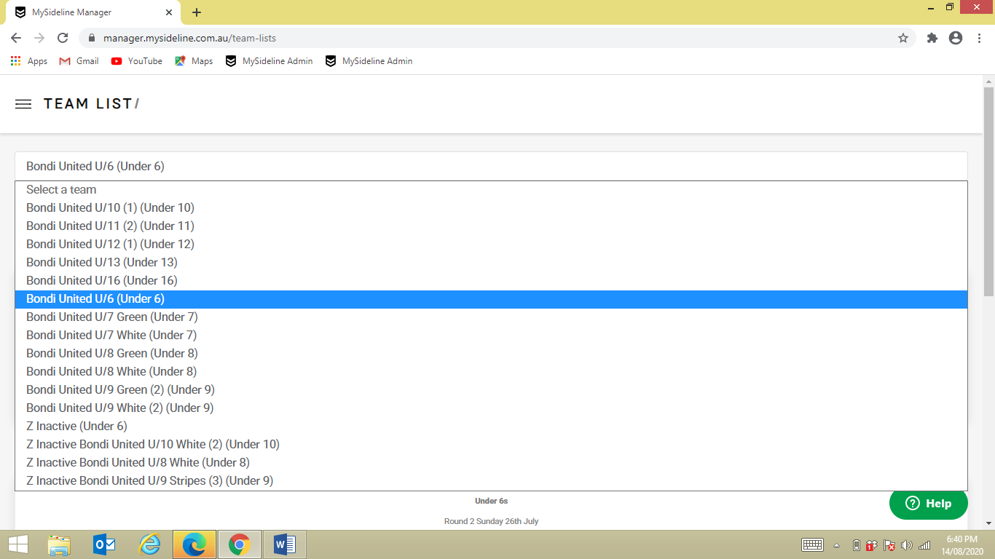
- Select Team

P 7

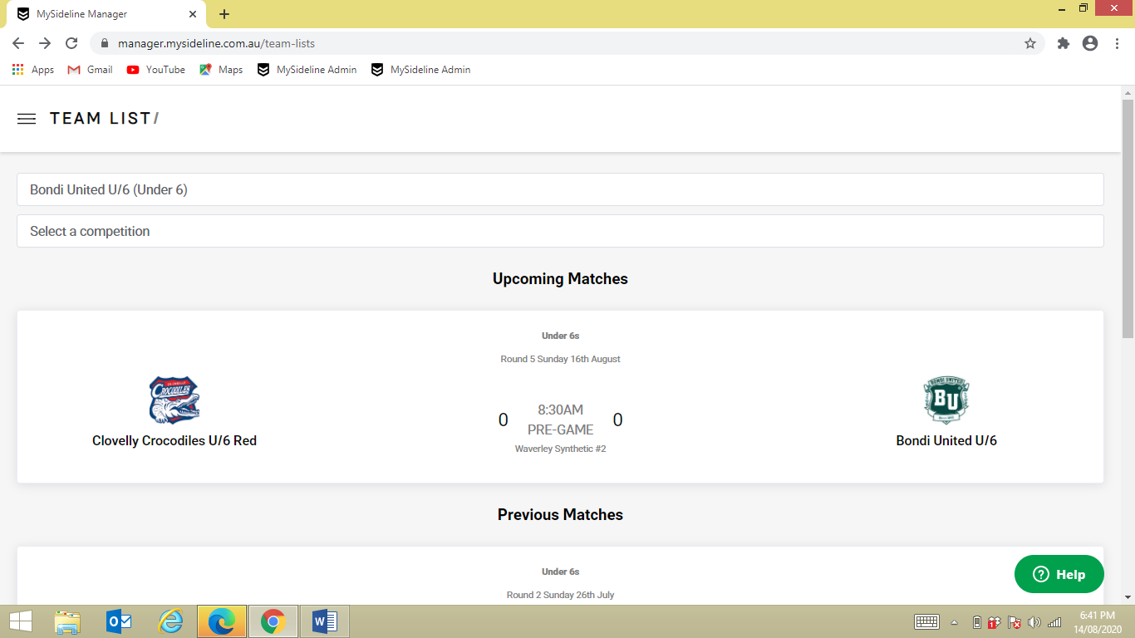
- Select Game Day

P 8

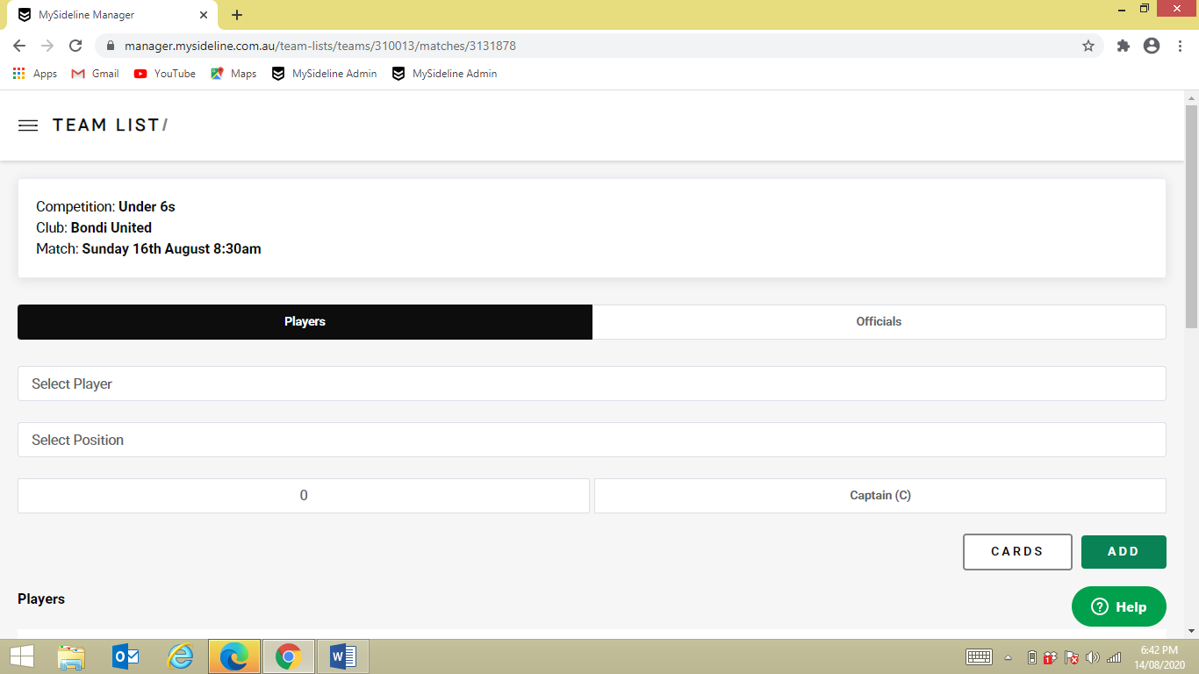
- Select Player

P 9

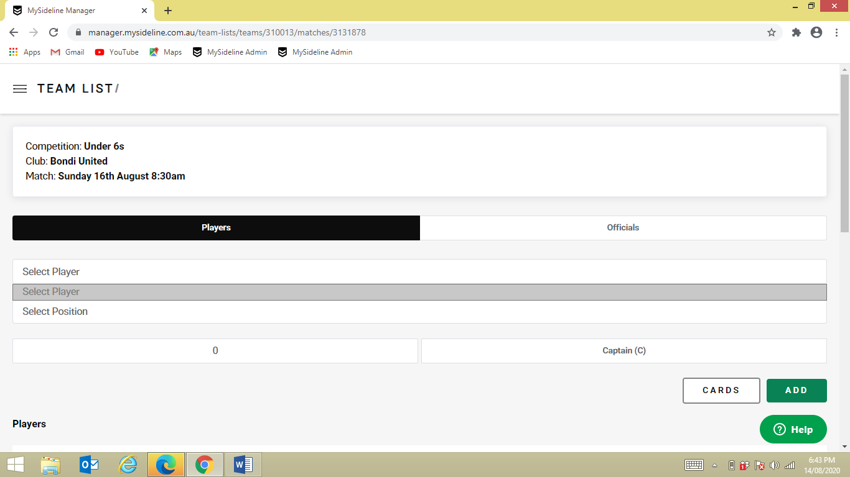
- Select Players Name if not on existing list

P 10

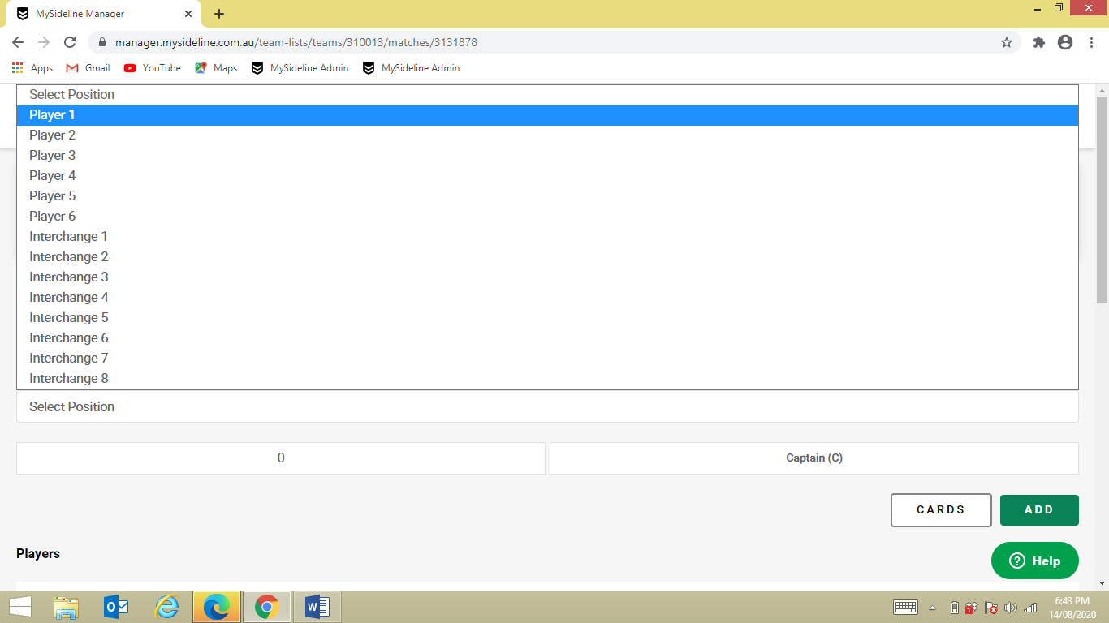
- Select the above players Position

P 11

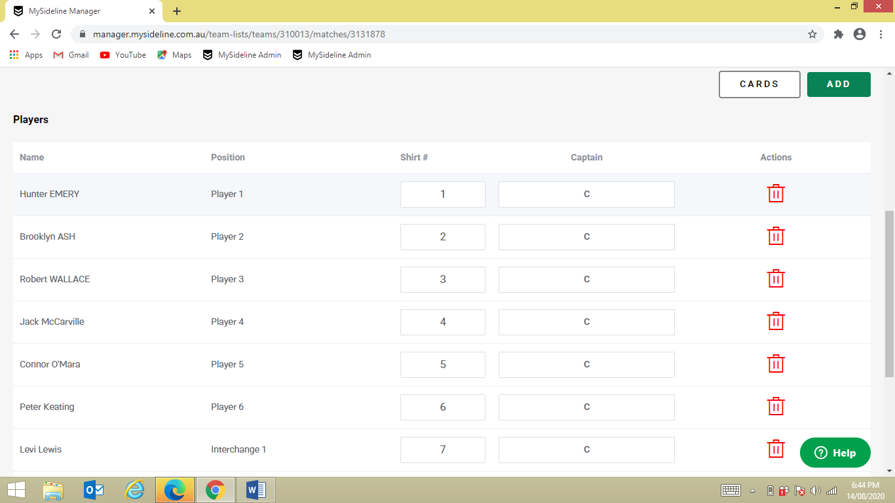
- Select ADD
- Then repeat process for each player if not on list

P 12

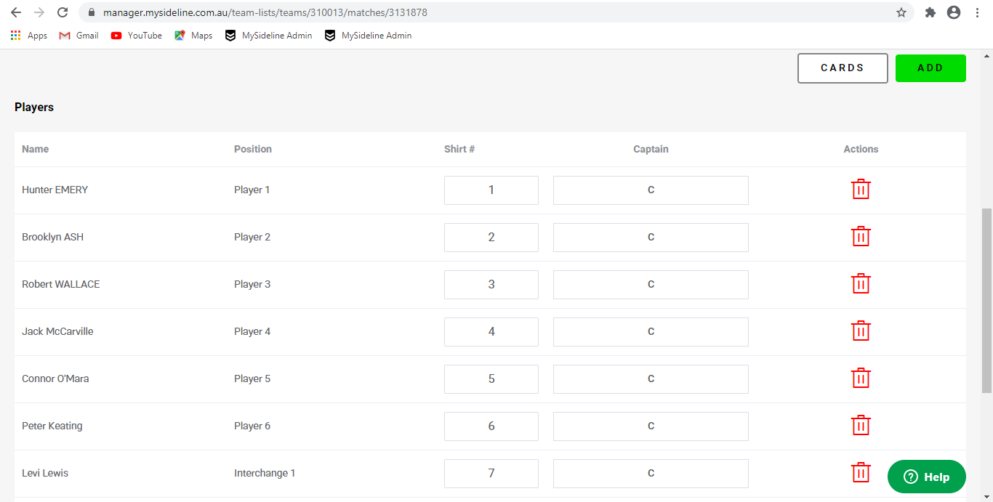

- If there are any players that can’t play that day, remove them off the list by selecting DELETE button against players name

P 13

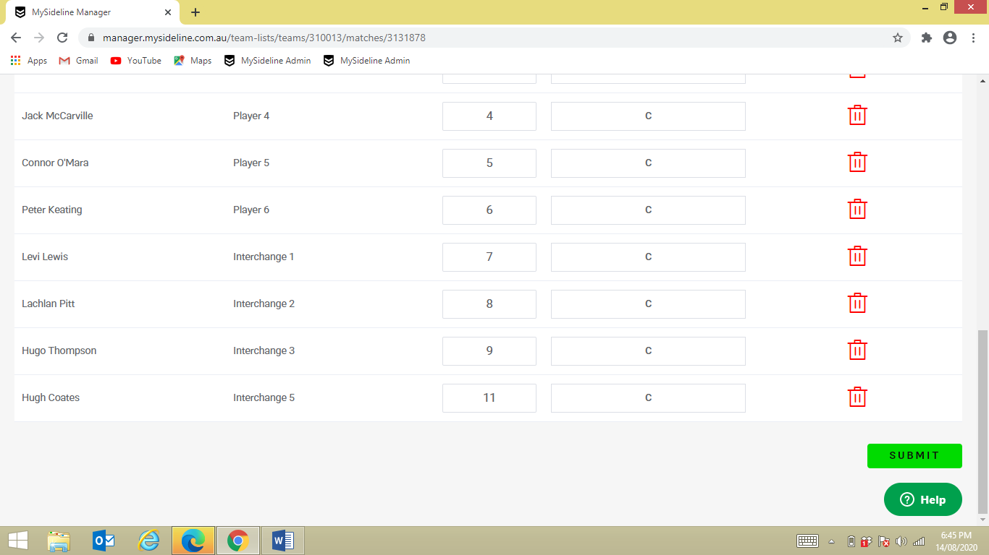
- Once you are happy with the Game Day Team List, select the SUBMIT button

P 14

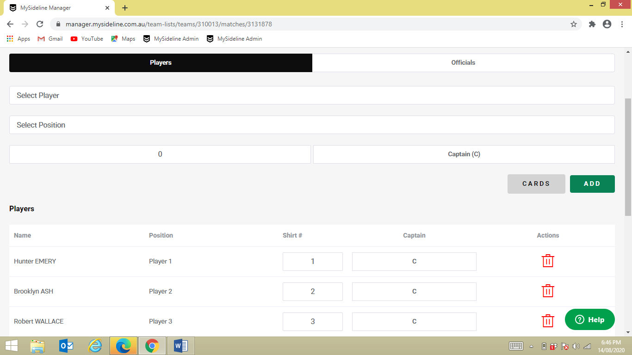
- Select CARDS

P 15

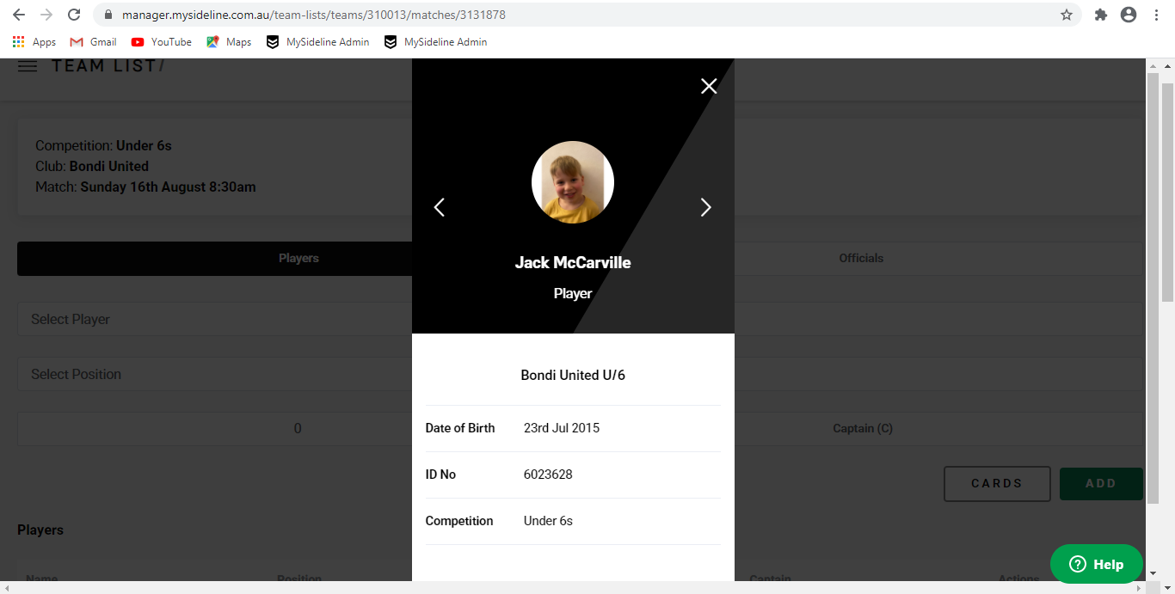

- Check all players photos are there

P 16

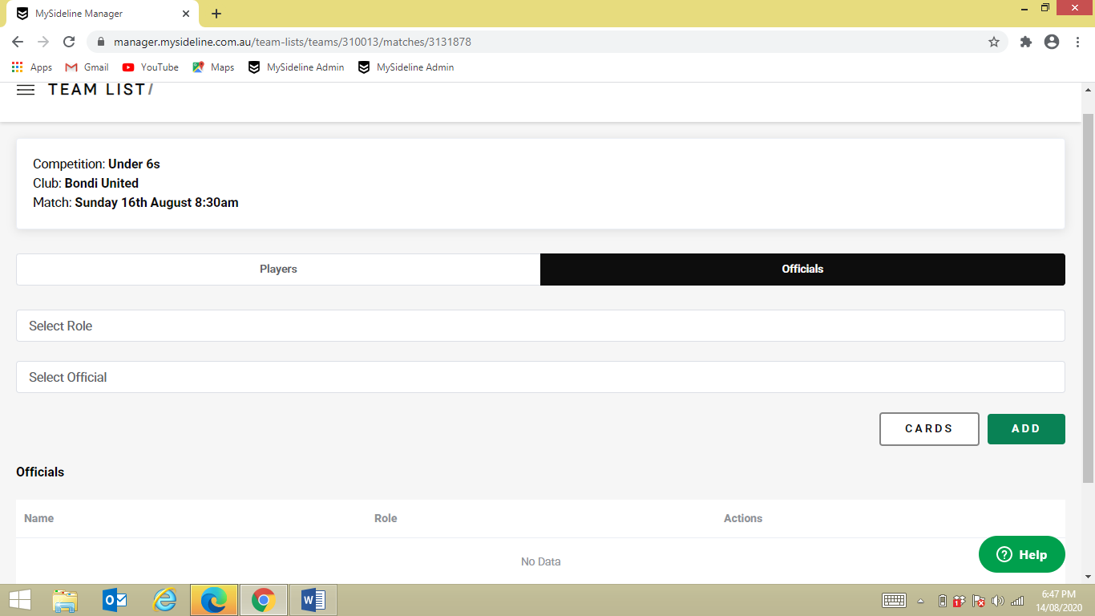
- Repeat process for the OFFICIALS

P 17

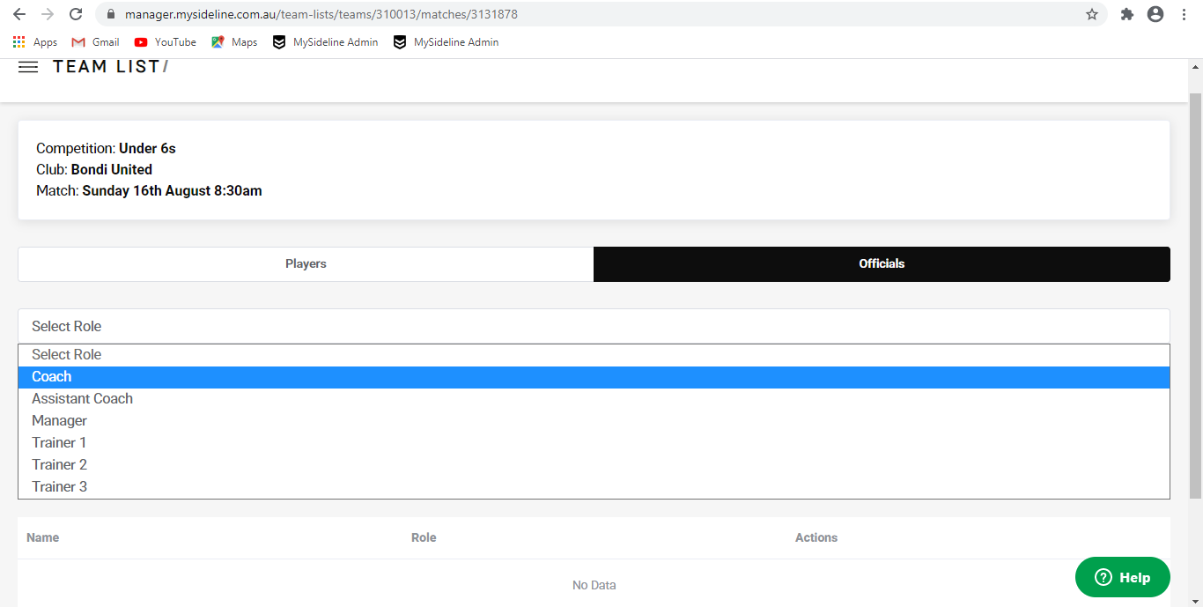
- Select officials ROLE – e.g. COACH

P 18

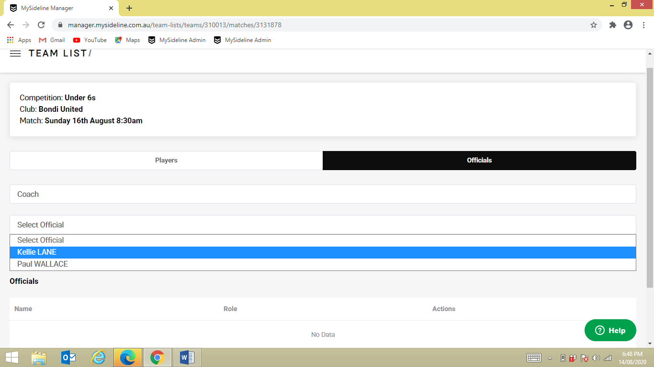
- Select person’s NAME

P 19

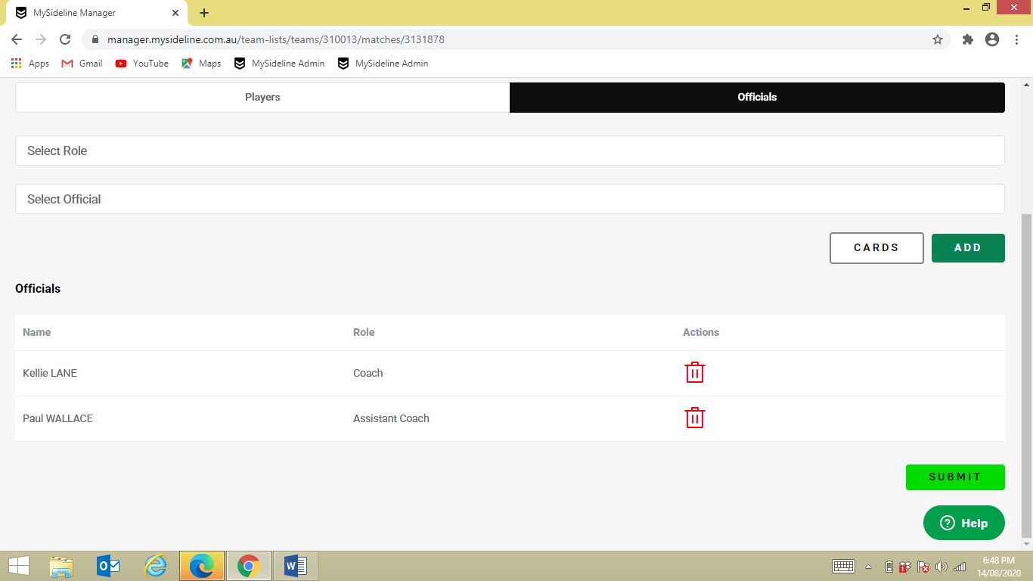
- Then ADD

P 20

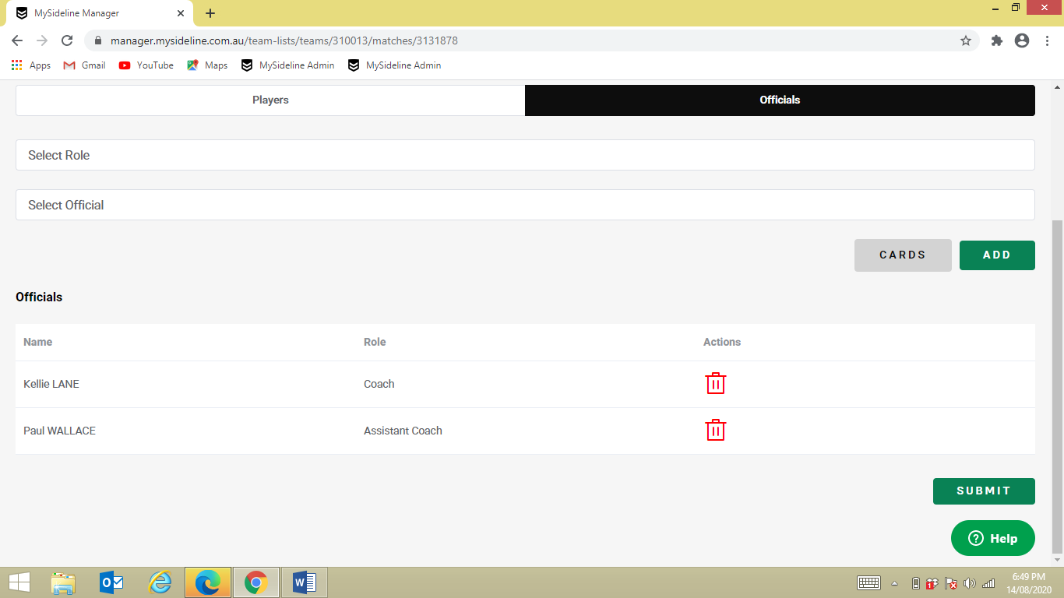
- Select SUBMIT

P 21

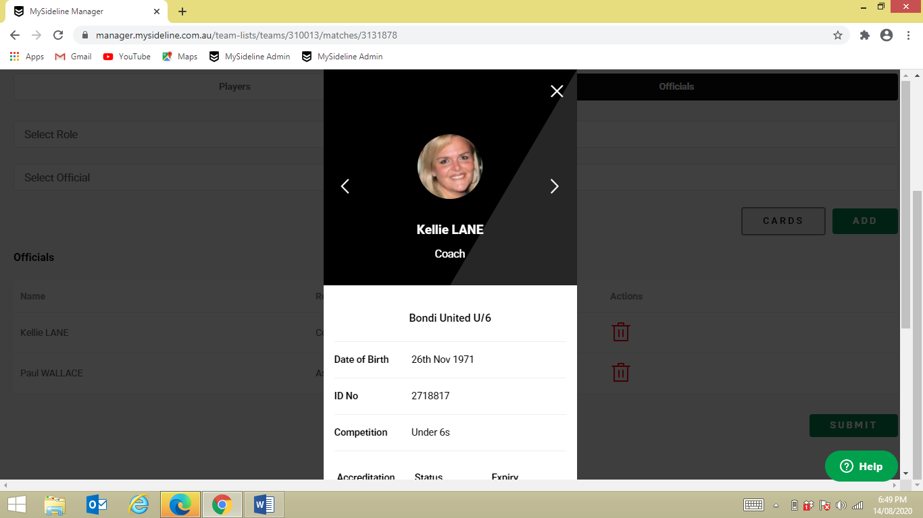
- Check officials photos and you are ready to go for game day

P 22
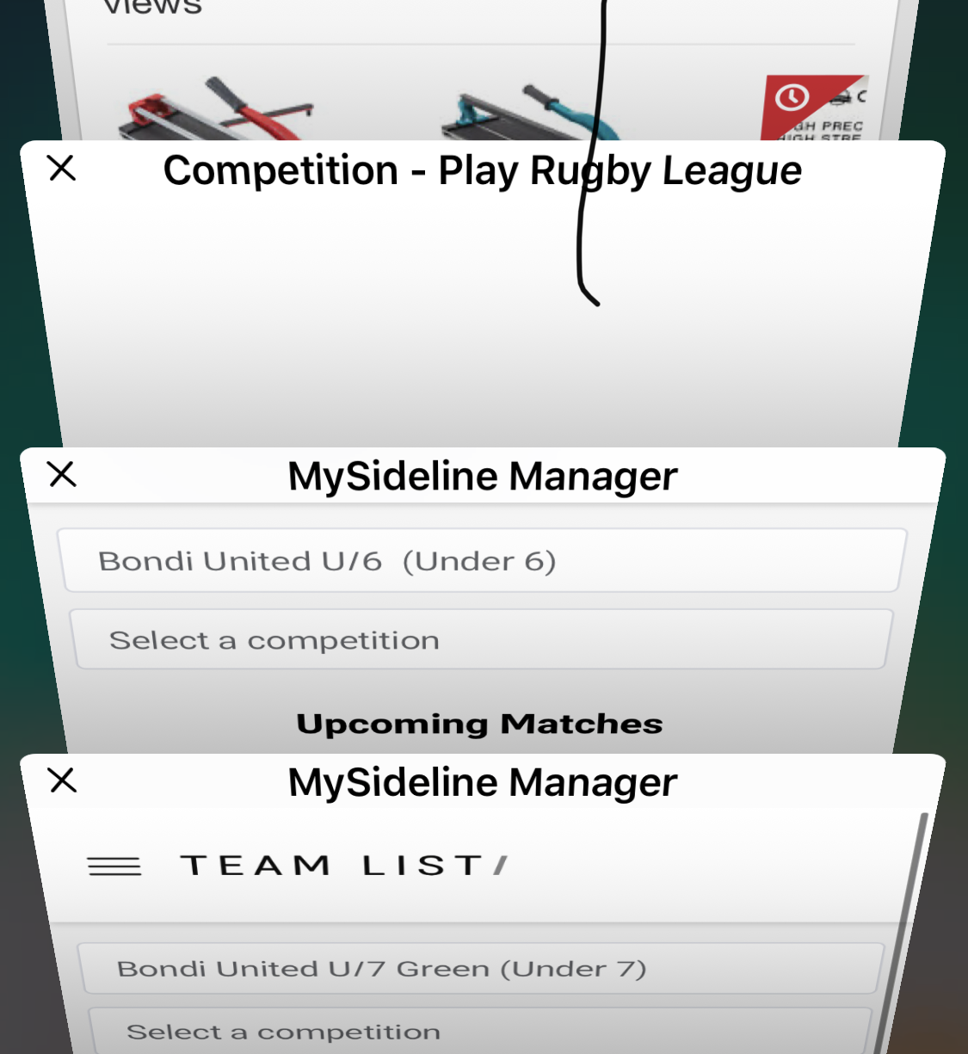

- Keep the web page open in your searches on your mobile, it makes it easier to pull players cards up

