SYDNEY ROOSTERS ADMINISTRATION – SYSTEM PROCEDURES
INJURY REPORT ONLINE
NOTE Paper form can also be completed and sent to your club secretary
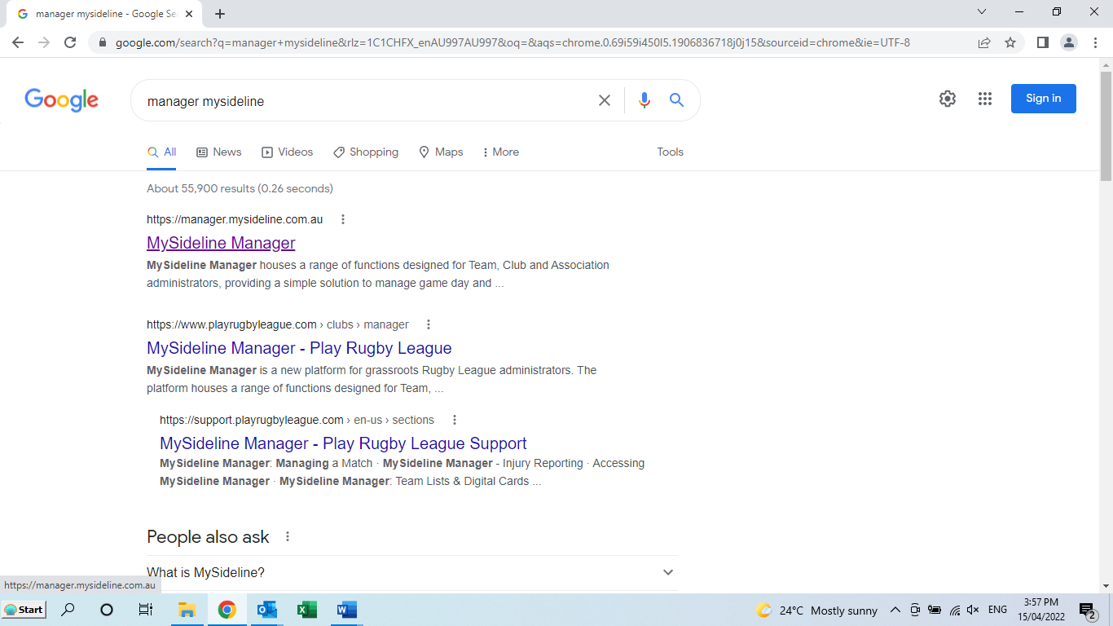
- Search www.manager.mysideline.com.au
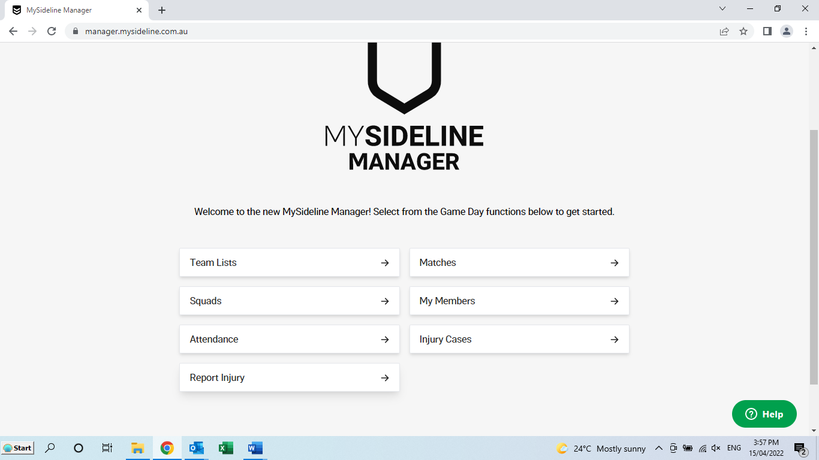
- Select REPORT INJURY
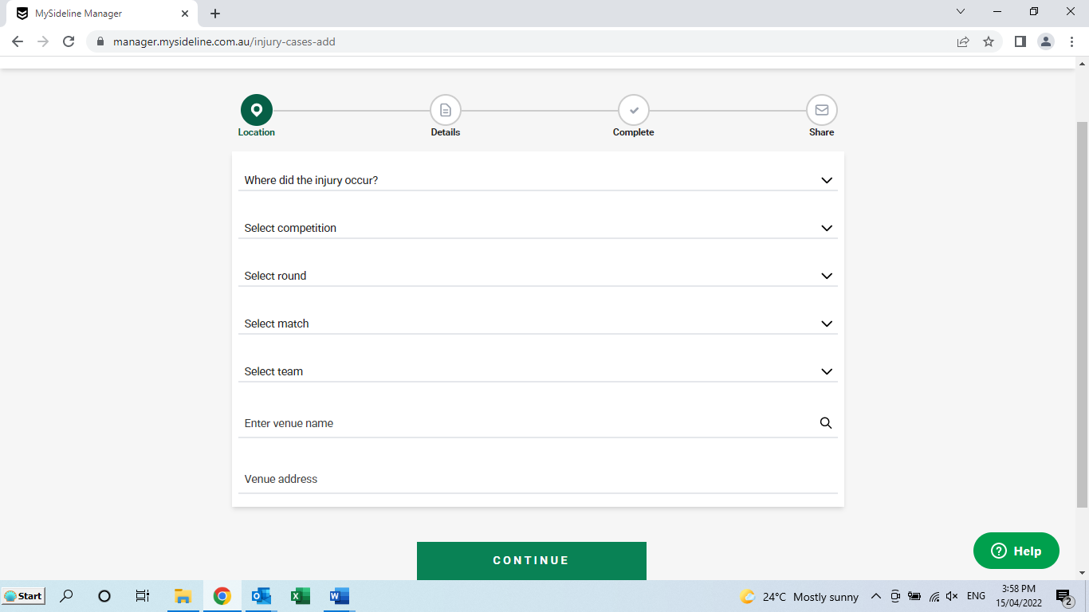
- Complete all information using the DROP DOWN BOXES
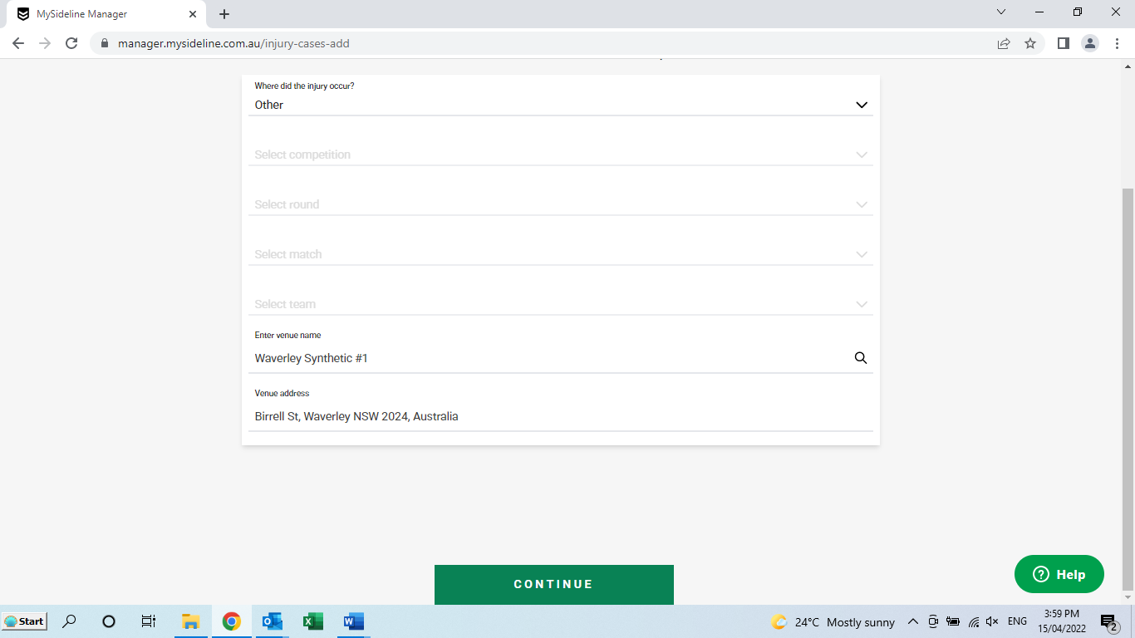
- Select CONTINUE
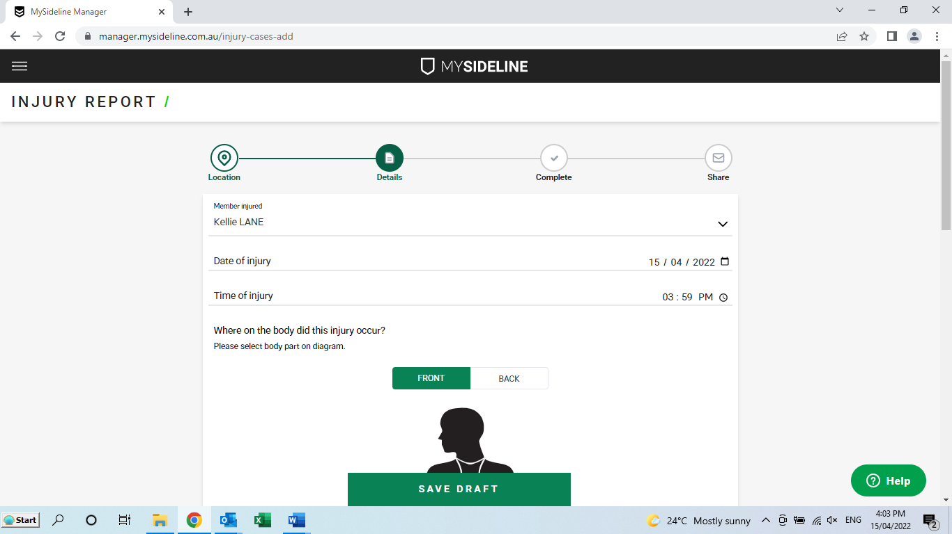
- Select MEMBER INJURED using DROP DOWN BOX
- Then enter DATE & TIME OF INJURY
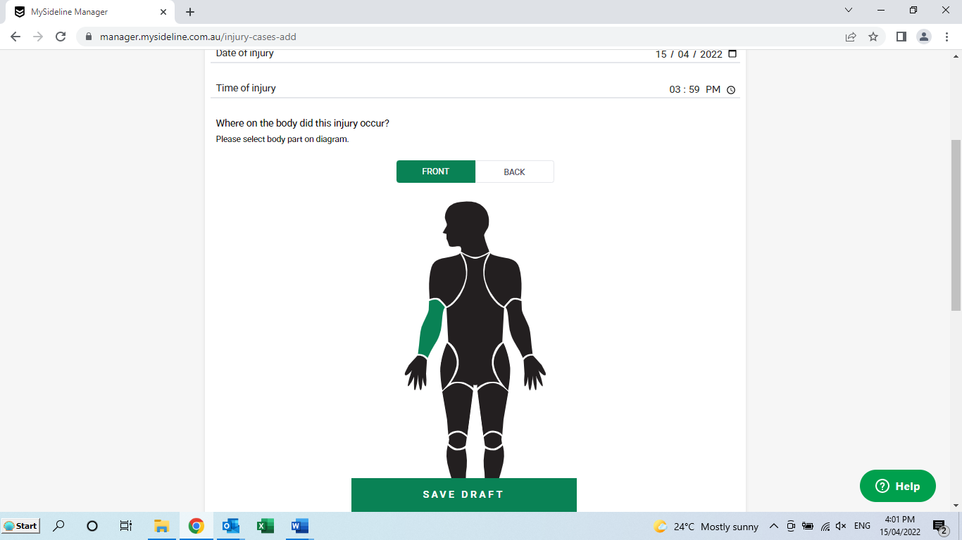
- Click on FRONT or BACK
- Click on the INJURED PART OF BODY
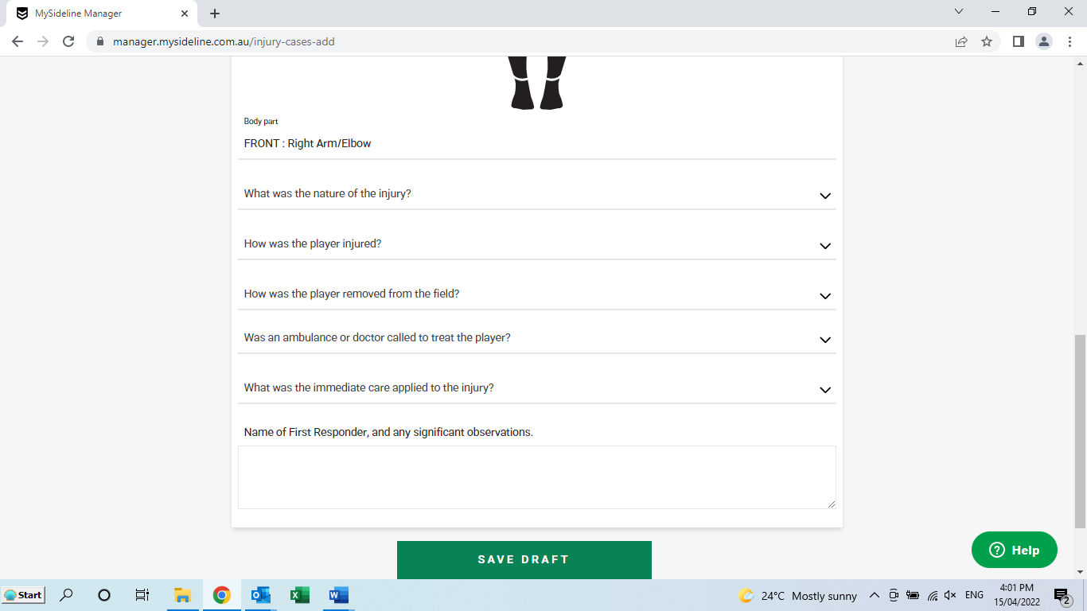
- Complete all information using the DROP DOWN BOXES
- Type in NAME OF FIRST RESPONDER AND ANY OTHER OBSERVATIONS
- Click on SAVE DRAFT

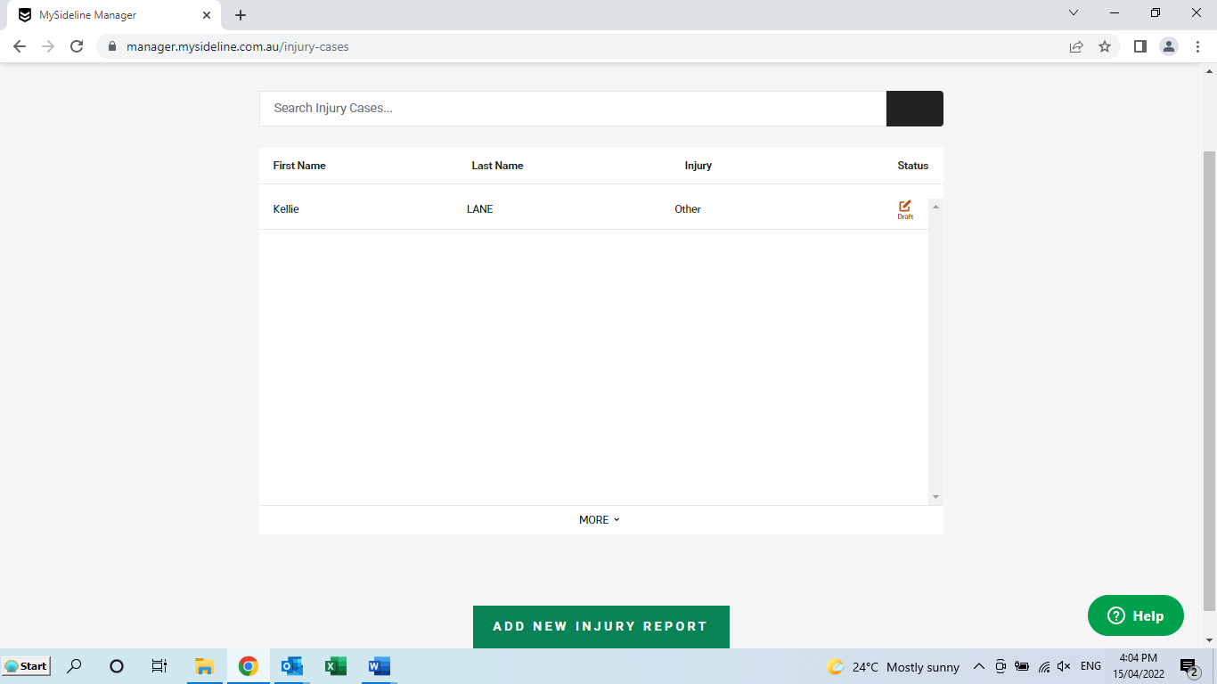
- Information is now SAVED
- Click on ADD NEW INJURY REPORT if you have another to enter

